Is 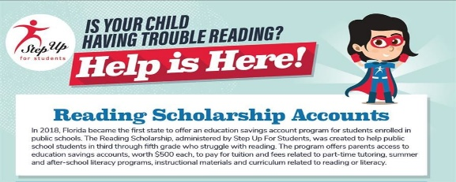

Dear Parent/Guardian,

You may now apply for the Reading Scholarship Accounts for the 2019-20 school year!

Go To: https://www.stepupforstudents.org/for-parents/reading-cholarship/how-the-scholarship-works/

Eligibility:
• Students who qualify are third through fifth graders in public school who scored a 1 or 2 on the third or fourth grade English Language Arts section of the Florida Standards Assessment in Spring 2019.
• Applications are processed on a first-come, first-served basis in the order all documents are received. Students who are classified as English Language Learners, and who are enrolled in a program or receiving services that are specifically designed to meet the instructional needs of English Language Learner students, will receive priority.

Reminders:
• To successfully complete the application, you will need the following information which can be found on your student’s Spring 2019 Florida Standards Assessment (FSA) report (see sample below to find the needed information):
1) Your student’s grade level at the time of the Spring 2019 Florida
Standards Assessment.
2) Your student’s Florida Education Identifier (FLEID) number.
3) The Department of Education School Choice Code for the school your student attended and was administered the Spring 2019 Florida Standards Assessment.
4) The school district ID number. (Note: This is typically a two-digit number.)
5) Your student’s Spring 2019 Florida Standards Assessment (FSA) English
Language Arts (ELA) performance level.
6) Your student’s Spring 2019 Florida Standards Assessment (FSA) English
Language Arts (ELA) score.

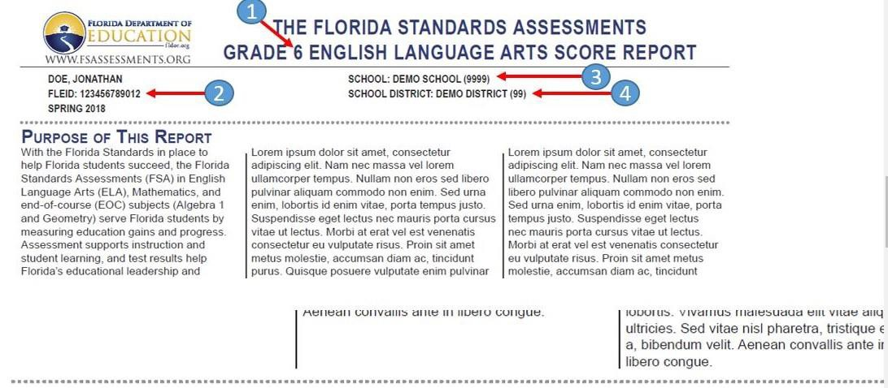

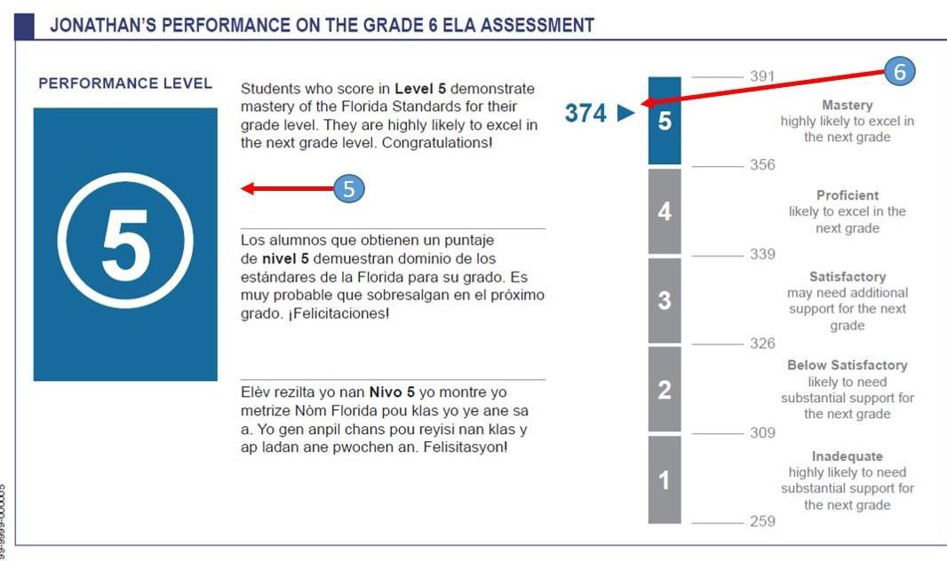

Failure to provide the above information will result in your application being found incomplete.
• Helpful tip: Although not required, we strongly recommend that you upload your student’s Spring 2019 Florida Standards Assessment to make processing more efficient.

If you have any questions, please contact us by email at reading@sufs.org or by calling our Service Center at 877-735-7837. Our Service Center is open Monday through Friday from 8:30 am. – 4:30 p.m. We are here to help you.

Best,

Step Up For Students

